***SQL QUERIES***

***1- What is the total amount each customer spent on the marketplace?***

**Solution-**

select s.user_id, sum(p.price) as total_amount

from sales as s

inner join products as p

on s.Product_id=p.Product_id

group by s.user_id

order by user_id

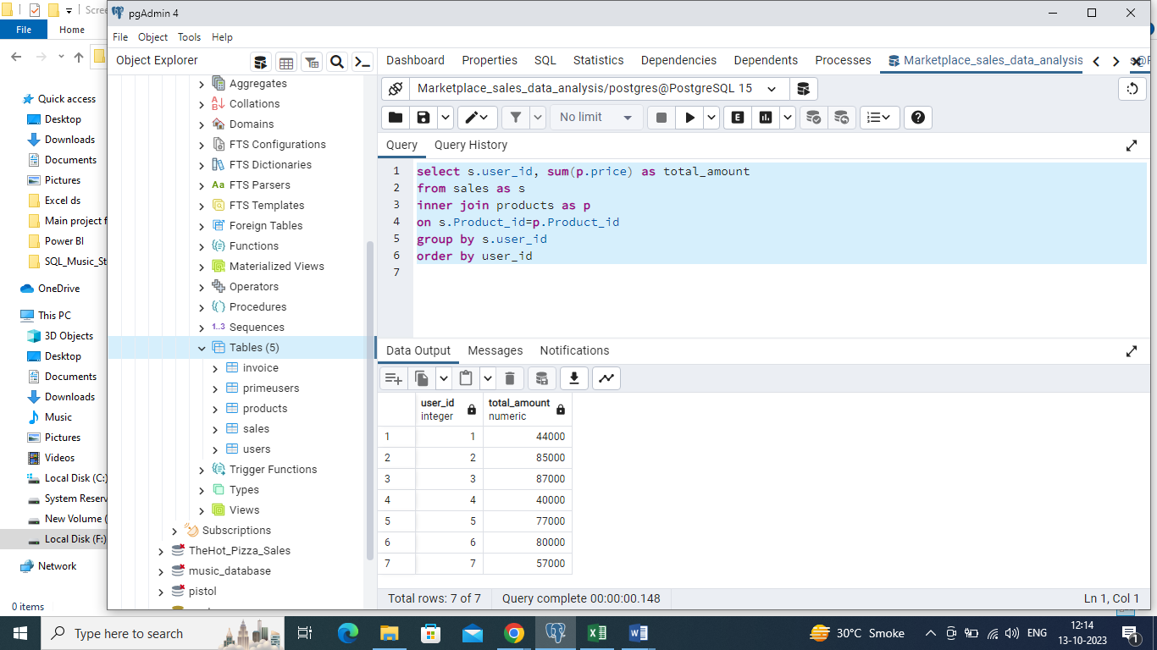

***2- how many days has each customer visited marketplace?***

**Solution-**

select user_id, count(distinct order_date)

from sales

group by user_id

order by user_id

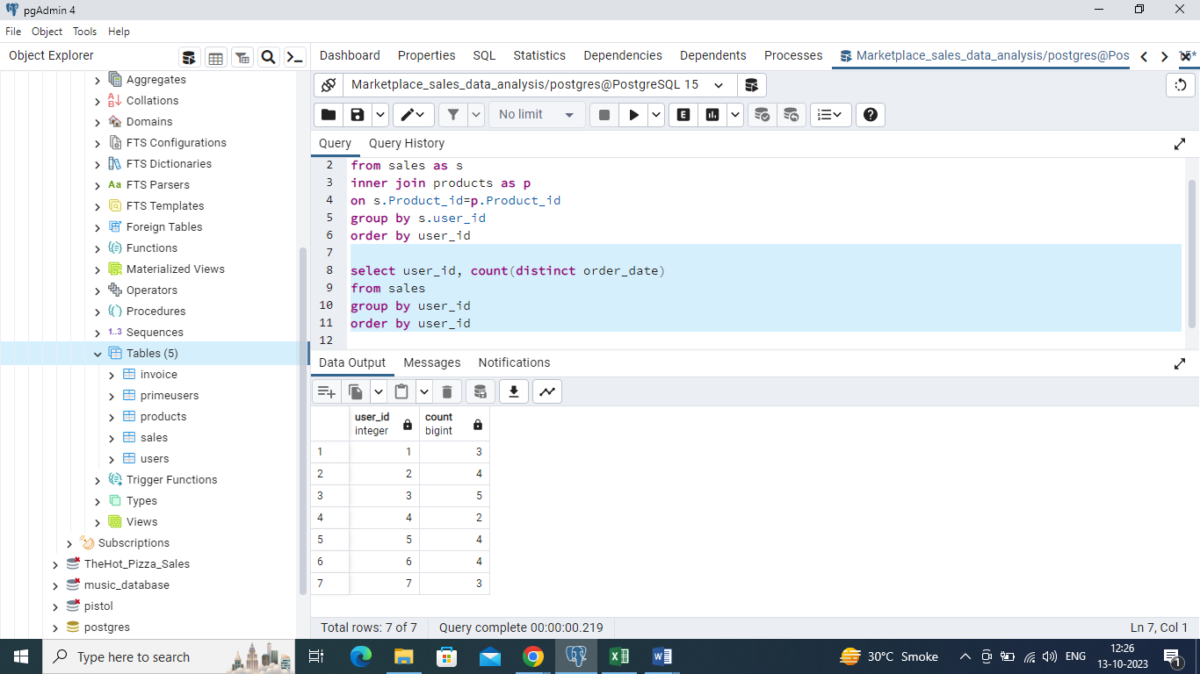

***3- what was the first product purchased by each customer?***

***Solution –***

with abc as

(

with cte as

(

select *,

rank() over(partition by user_id order by order_date) as R

from sales)

select user_id, order_date,product_id, R from cte

where R = 1)

select abc.user_id, abc.order_date, abc.product_id, products.product_name

from abc

join products

on abc.product_id=products.product_id

order by abc.user_id

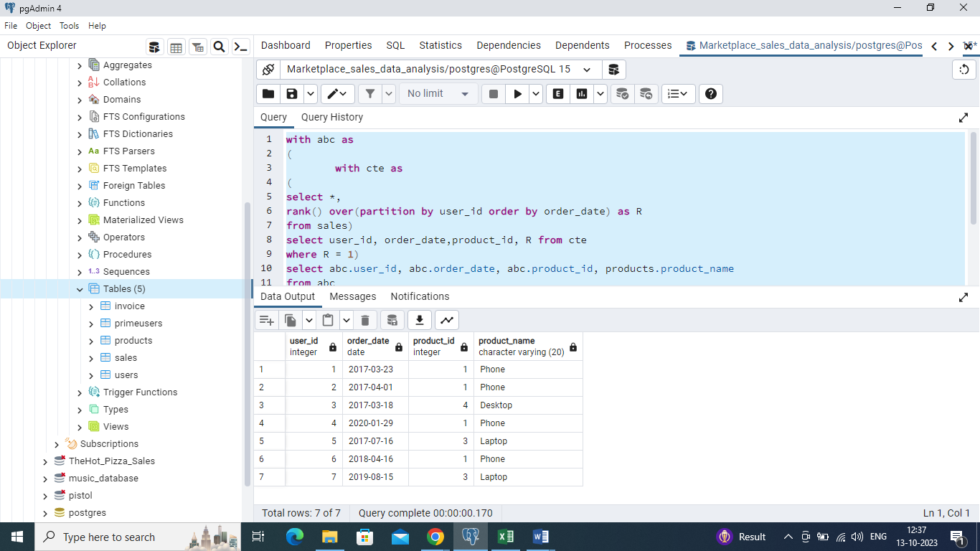

***4- (a) What is the most purchased item on the menu and ,***

***(b) How many times was it purchased by all customers?***

***Solution (a)-***

with def as

(

with abc as

(

select product_id, count(product_id) over(partition by product_id) as product_count

from sales

order by product_id

)

select distinct(product_id), product_count from abc

order by product_id

limit 1

)

select product_count, products.*

from def

join products

on def.product_id=products.product_id

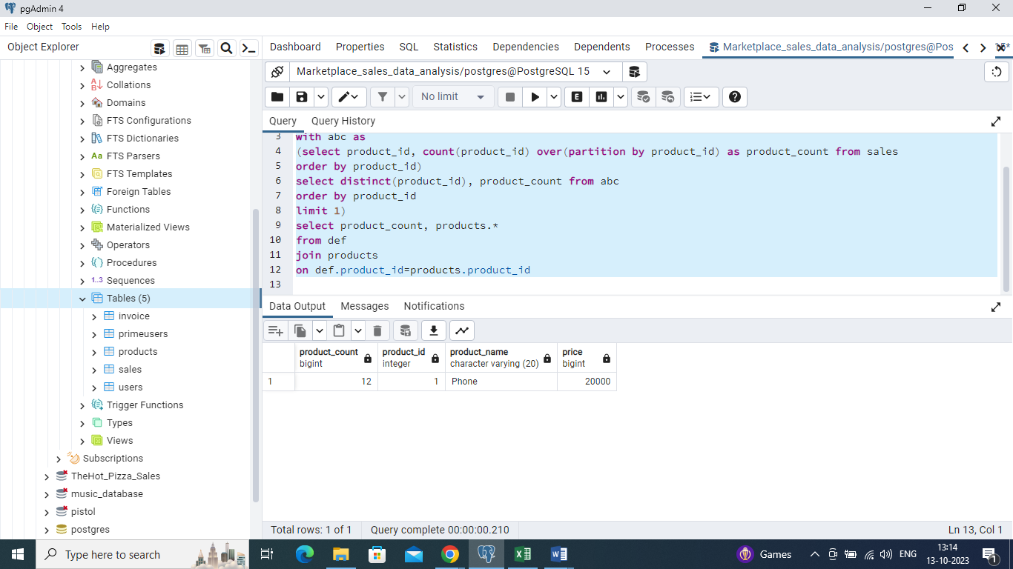

***Solution (b) –***

with abc as

(

select distinct(product_id),

count(product_id) over(partition by product_id) as product_count from sales

order by product_count desc

limit 1

)

select count(sales.product_id), sales.user_id

from abc

join sales

on abc.product_id=sales.product_id

group by sales.user_id

order by sales.user_id

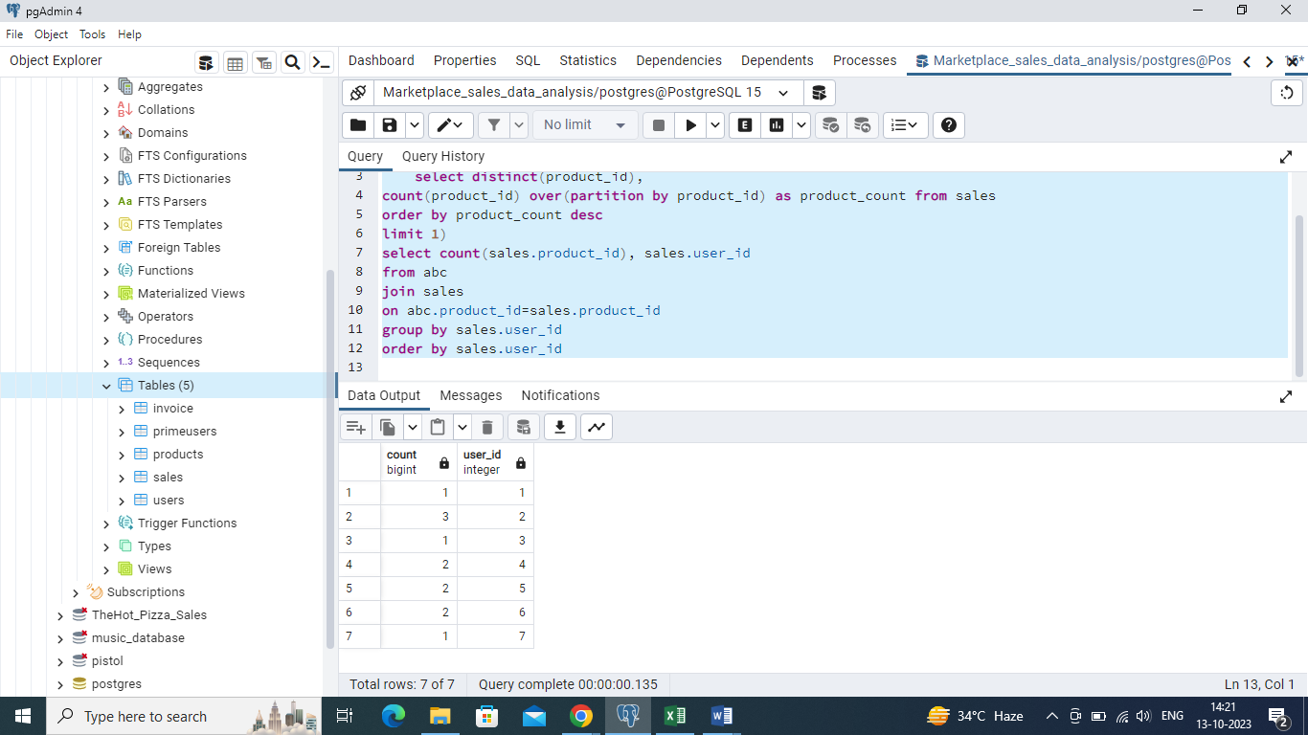

***Q5- which item was the most popular for each customer?***

***Solution –***

with def as

(

with abc as

(

select user_id, product_id from sales

order by user_id)

select *,

max(product_id) over(partition by user_id order by user_id) as maximum_product_id

from abc)

select distinct(user_id), maximum_product_id from def

order by user_id

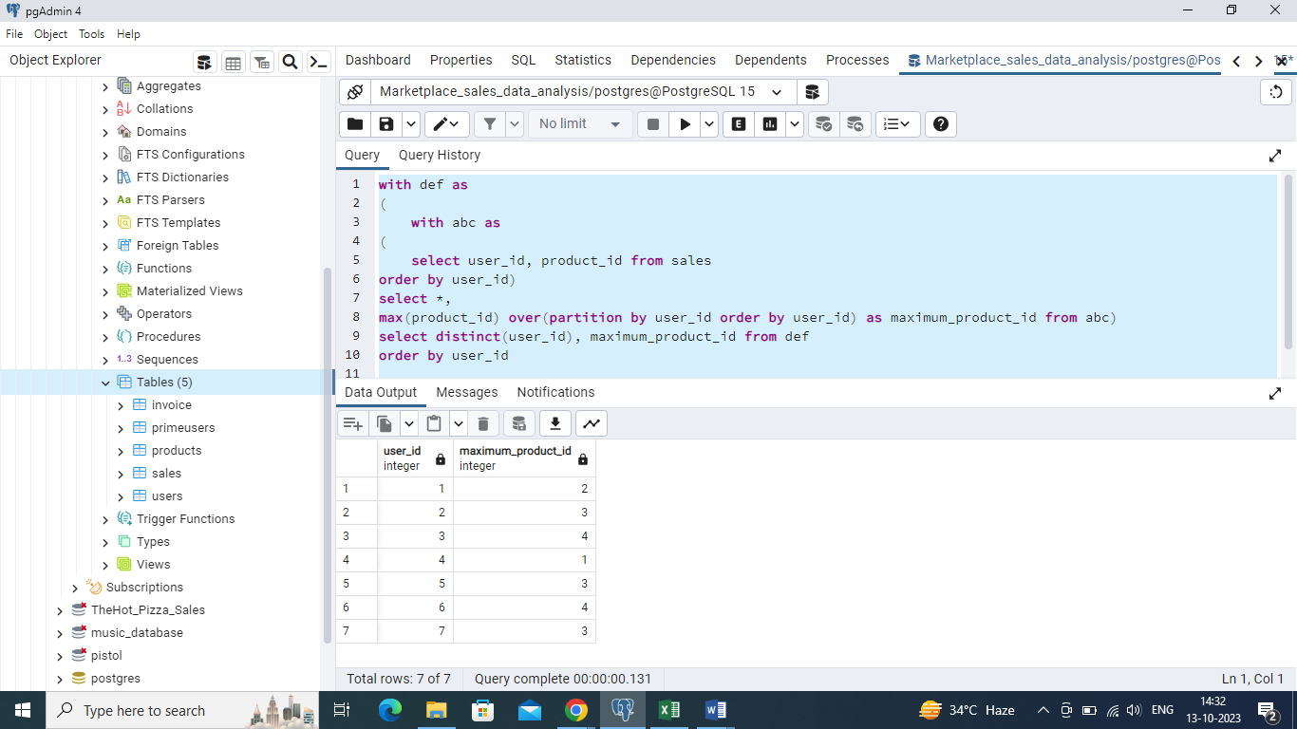

***Q6- list of invoices of prime users and their billing state.***

***Solution –***

with abc as

(

select *

from primeusers as p

join invoice as i

on p.user_id=i.user_id

)

select invoice_id, billing_state from abc

order by invoice_id

